1. **Agenda**:
   1. Producer would add integers to an Array List.
   2. Consumer would consume them.
2. 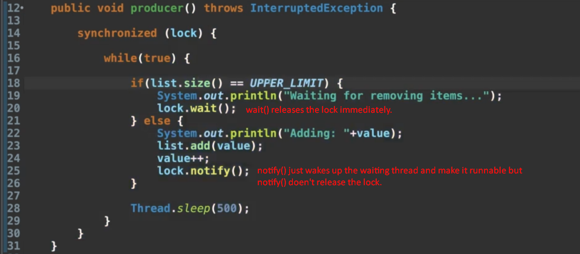
3. 